
Център за обучение по софтуерно тестване Website: http://skillo-bg.com
Bug Template
Bug ID | PSB002
Name | When playing Packman, after being killed, the number of hearts remaining is not changing.
Priority | P1
Severity | S4
Description
Steps to reproduce | - Load URL: https://glitchplay.com/  - Click on “Play” button  - Click on the field of the game to start the game  - Start moving Pacman around the playing field to hit a ghost  Expected result: Pacman is killed and the number of hearts (number of lives) above the playing field is reduced by one.  Actual result: Pacman is killed, but the number of hearts is not reduced.
Attachment | 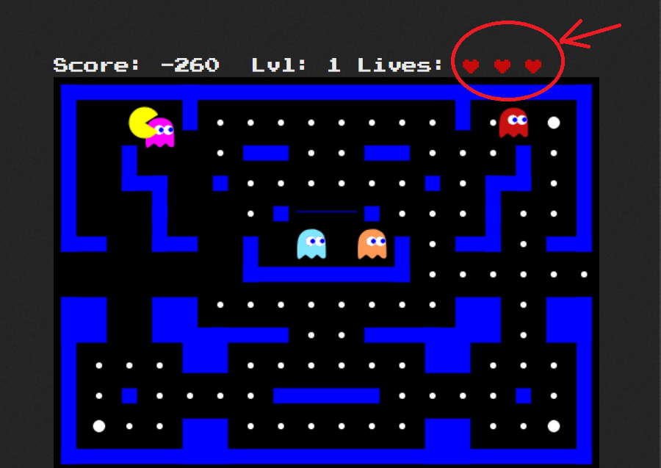
Status | New
Component | Gameplay
Version/Build number (Found in) | Google Chrome  Version 73.0.3683.103 (Official Build) (64-bit)
Environment | Google Chrome
Comments
Date Created | 18/04/2019
Author | Ralitsa Parshorova
Audit Log

